**ASSIGNMENT 2.1**

PROBLEM STATEMENT:

**1) (i) Check whether /user/acadgild directory exists or not in the HDFS. If it doesn't exist, then create this.**

Solution:

target_dir = /user/acadgild

hadoop fs -test -d ${target_dir}

echo $?

Since it gives 0 as the output so, it means that ‘/user/acdgild’ directory exist

Output:

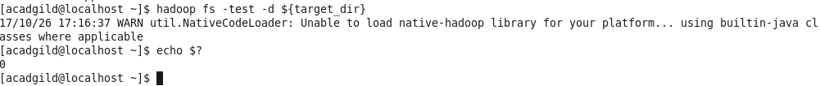

**(ii) Create a directory /user/acadgild/hadoop.**

Solution:

hadoop fs -mkdir /user/acadgild/hadoop

By writing and executing the above commands, we can create the above directory.

Output:

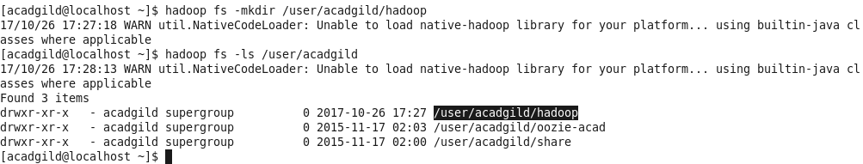

**2) Create a file in HDFS under directory /user/acadgild/hadoop, with name word-count.txt.**

**Whatever we type on screen should get appended to the file.**

**Try to type (on screen) few lines from any online article or textbook.**

Solution:

(i) Create a file in HDFS under directory /user/acadgild/hadoop, with name word-count.txt.

hadoop fs -touchz /user/acadgild/hadoop/word-count.txt

Output:



(ii) Whatever we type on screen should get appended to the file. Try to type (on screen) few lines from any online article or textbook.

Solution:

Output:

